Holiday Inn Lincoln
Celebrations and Events

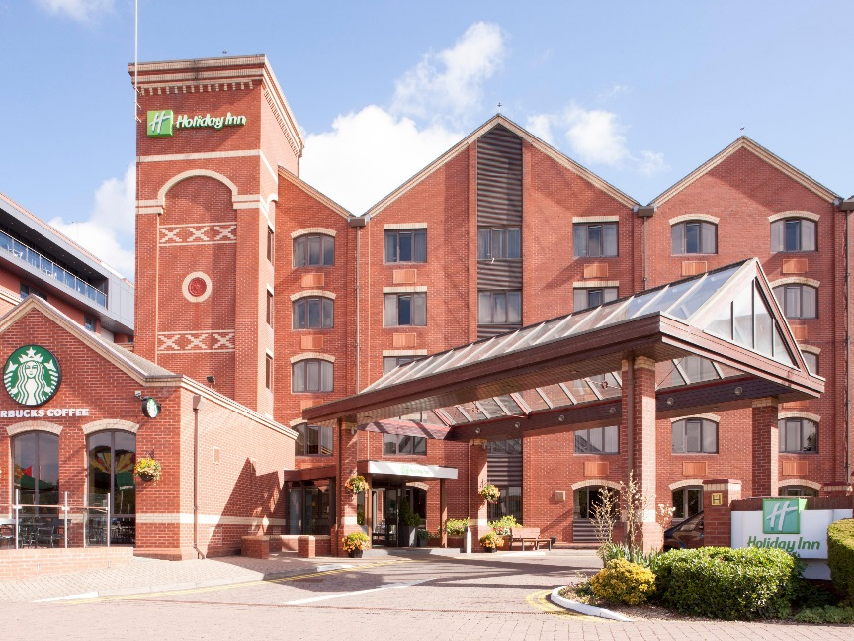

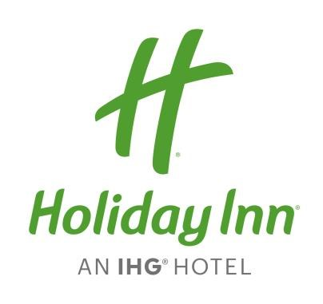

Brayford Wharf North LN1 1YW (LN11XL) for SatNavs Telephone: 01522544244
Email: marketing.hilincoln@kewgreen.co.uk Website: www.hilincoln.co.uk

Parking at the hotel is complimentary for guests attending events and is Parking Eye monitored vehicles MUST be registered at reception upon arrival. Access car park using LN11XL in your sat nav & drive along waterfront. We do require you to register your car details at reception on arrival as we have an external security company called Parking Eye who will charge £100 if the car is not registered on their system.
This hotel is owned and operated by Kew Green (Square) Ltd under licence from IHG Hotels Ltd

Brayford View

Private Hire
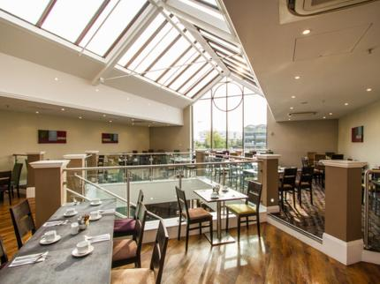

We are delighted that you are considering the Holiday Inn Lincoln for your forthcoming event.
Our Sales Office Manager will be delighted to invite you to the hotel to see our scenic and unique venue to help you plan your event and assist you with every step to ensure that your event is a success. We can cater for a wide range of events and tastes in our beautiful Brayford View Restaurant.

Comfortably seating 80 with a disco and dance floor upstairs
Or 100 with either no disco or disco and dance floor located in the below Sports Bar.

In choosing the Holiday Inn Lincoln, we can assure you of the finest service and facilities that are second to none.

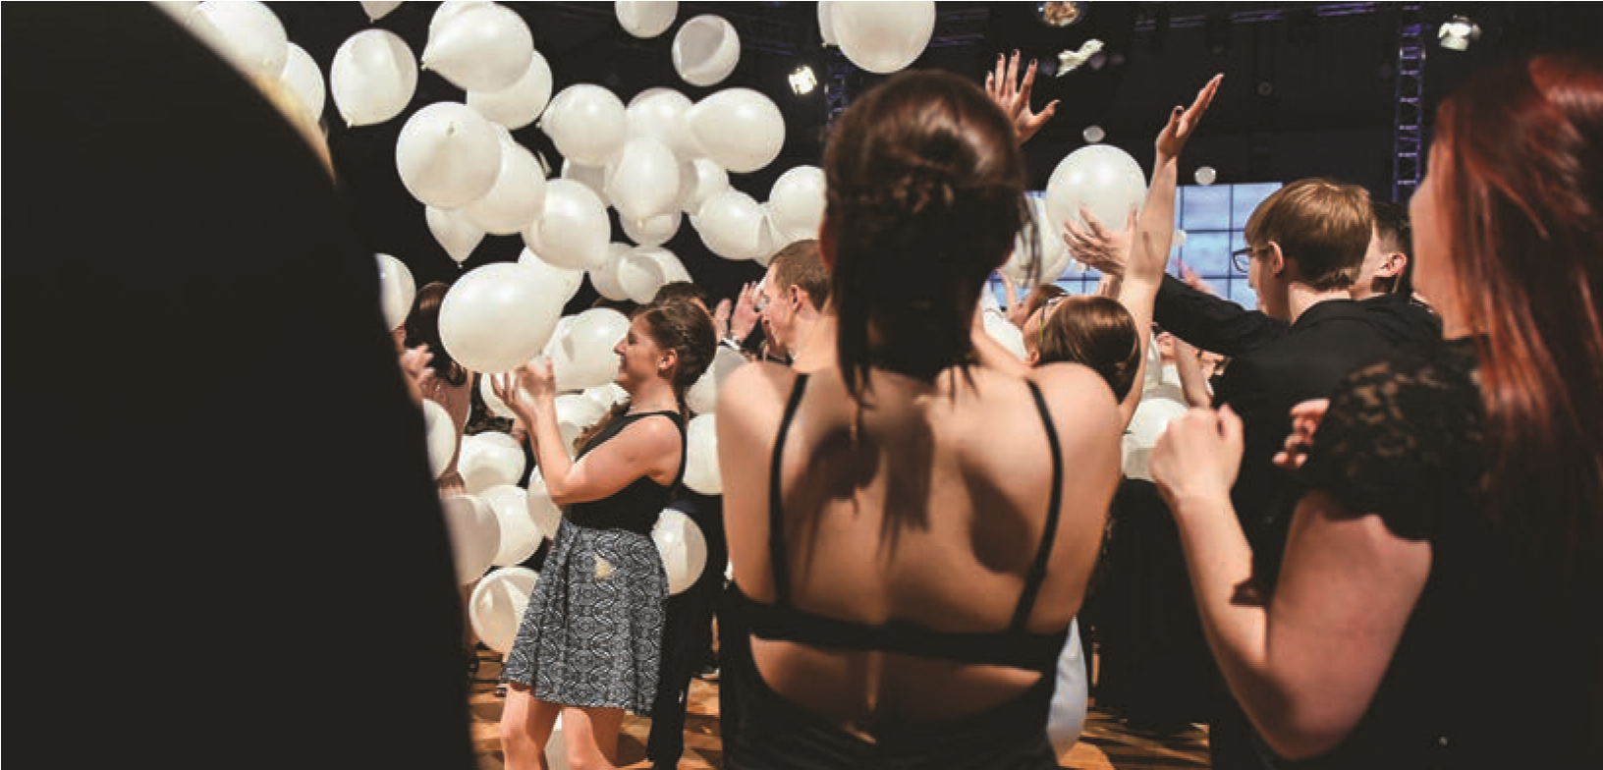

Brayford View

Private Hire & Entertainment

Host your event in our stunning Brayford View Restaurant with floor to ceiling windows and picturesque views over the Brayford Waterfront.
Whether your event be a reunion, birthday party, christening or to celebrate a life.

We have contacts with local reputable companies for all types of entertainment including:

- Themed Disco
- Karaoke
- Tribute Acts
- Children’s Parties
- Hog Roasts

Free room hire when booking a private event in our Brayford View.
T’s and C’s apply.
Should you wish to book a function with the hotel a £200 deposit is due within 2 weeks of making a provisional booking and the final balance payment will be due 4 weeks prior to the event.
Please note should you bring your own entertainment the hotel requires proof of liability cover, must be received 8 weeks prior to the event.

Accommodation & Corporate

We have 98 spacious bedrooms, all having ensuite facilities, TV, iron and ironing board and tea & coffee making facilities. Room upgrades and Brayford Waterfront rooms are also available, subject to availability and rate. Our executive rooms guarantee you beautiful views overlooking the Brayford waterfront. Consisting of upgraded bathroom amenities, bathrobes and slippers, mini fridge with complimentary bottled water and a chocolate snack, comfortable sofa and a pinpad lockable safe.

Bed and Breakfast packages are available; our Holiday Inn buffet breakfast has over 50 items available so there really is something for everyone.
We cater for special dietary requirements too, please let us know prior to your arrival.
Our groups reservations department can create you your very own booking link for you to pass on to your guests.
This will make organising your rooms so much easier and give you one less thing to worry about.

We are also delighted to offer you a preferential accommodation rate for you and your guests when attending a function. Please ask your coordinator for rates available.

Here on business? Tell us about your corporate requirements and we can offer you rates to suit.

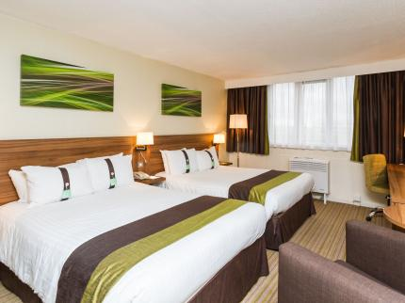
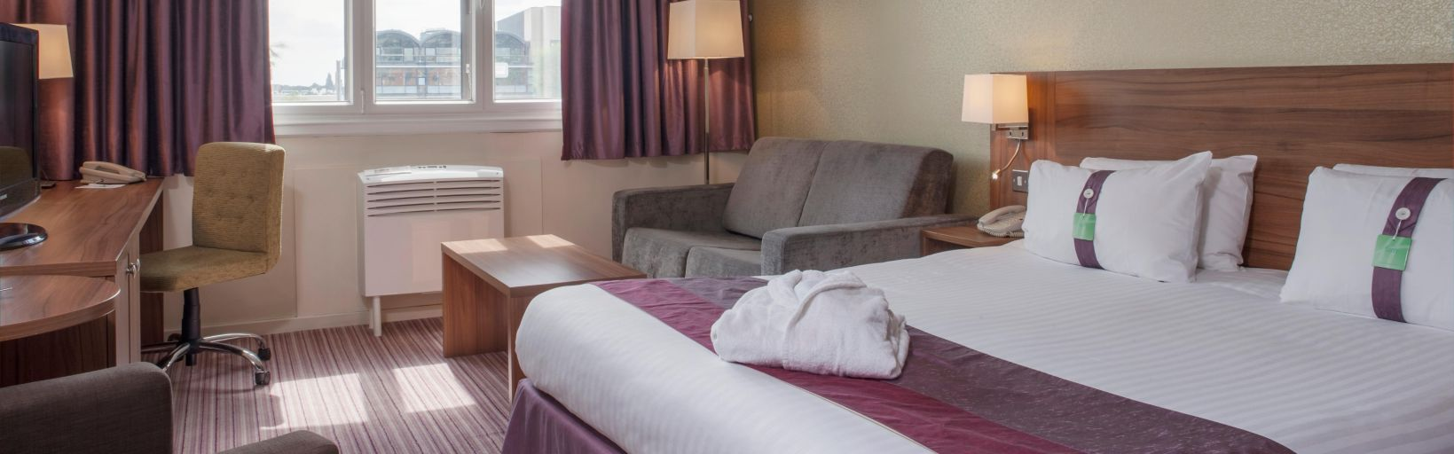

Make My Party Extra Special

Why not add on a glass of fizz for that special toast, save space for midnight bacon baps and keep the kids happy with something a little sweet.
Optional Extras:

Bucks Fizz | £3.50pp
Sparkling Wine | £3.50pp
Champagne | £8.00pp
Bottega mini bottles | £9.95 Per mini bottle
Tea and Coffee Course  Cheese Boards  Midnight Bacon Bap’s  Cupcakes | £2.00pp  £5.00pp  £5.00pp  £6.00 a Dozen  Further party extras we can supply: Chocolate fountains, Popcorn maker, sweetie stations, fruit platers and ice cream pots.

Tailor-made packages

£9.95pp
Light bites buffet

£15.00pp
2 course Table d’hote

£18.00pp
3 course Table d’hote

£49.95pp
The All Inclusive
3 Course meal including open bar for 4 hours 8pm-12am, dance floor and disco

Minimum numbers apply

Speak to our Sales Office Manager about:

Funeral Tea packages available from £9.95pp
Buffet Lunches available from £8.00pp
Personalised Homemade Cakes and Cupcakes, prices dependent on requirement.
Lunches with personalised Menu’s and dietary requirements.

Afternoon Tea now available prices are subject to availability
